Step 1 – Register on the HP ExpertOne site
  - All new HP Institute students must register on HP’s My ExpertOne portal. Click on the following link to begin that process. https://www.myexpertone.com/forms/joinHPExpertOne.aspx?pc=HPIreg
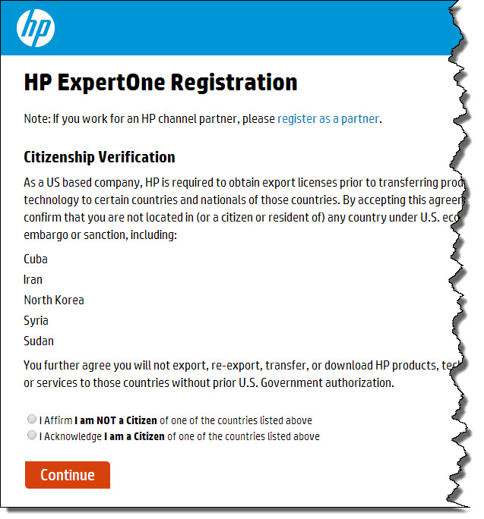
  - Verify your citizenship by selecting the appropriate affirmation/acknowledgement bubble and then click Continue
  - Complete the registration form on the next page and click Continue
  - Accept the Export Compliance Agreement by clicking on the “I affirm…” check box at the bottom of the page
  - Then on the next page agree to the terms and conditions by checking both boxes and clicking Submit
  - You will receive a confirmation email, which we suggest you save for future reference
  - Wait for the email issuing you your HP Learner ID (Important note: Please allow up to three business days for this notification email to arrive. If it has not arrived within three business days contact Certiport at HPATA@certiport.com.)
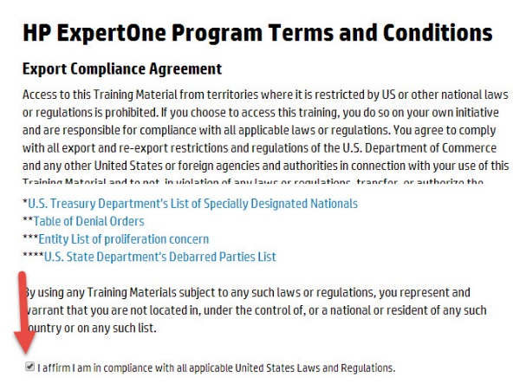
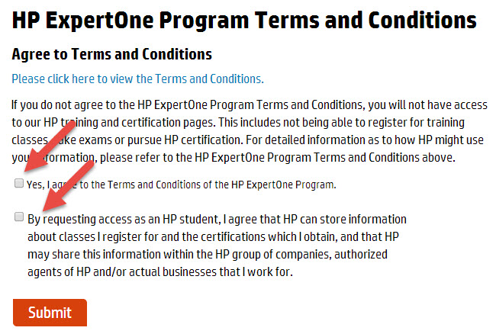

Step 2 – Explore the MyExpertOne portal
The MyExpertOne portal will be the main point of access for all your HP Institute student resources
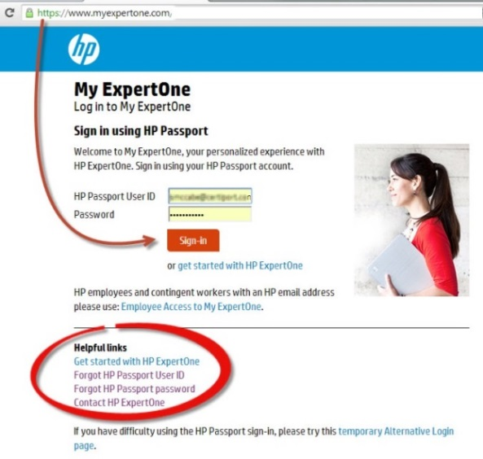

  - Go to www.MyExpertOne.com and enter your login credentials
    - Use the links in the Helpful links section of the page in case of forgotten User ID or Password
    - You need to have an HP Learner ID to access MyExpetOne. If you do not have one go back to Step 1 and register.
  - After you are logged in, move your cursor over the Training tab in the menu bar. In the drop down menu that appears click on the HP Institute resources option. This will direct you to the HP Institute-specific audience main page where you will be able to access HP Press eBook courseware and Lab Videos (see Step 5).
  - HP Press is the site where you download the eBook and access other learning resources. To do so, you first need to create an HP Press account (see Step 3). Click on the Sign in to HP Press link to create that account now. The directions do so continue below in Step 3 below.
