IN Class EXAM 2 REVIEW
Use the Fact database to answer the following. (hint you will need to download it and install it on your UARK EPIC account)

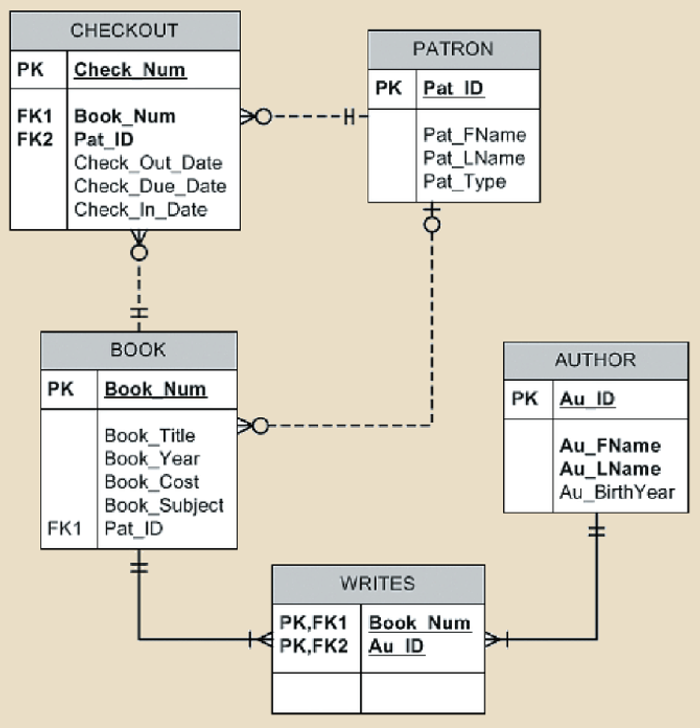

- Write a query that displays the book title, cost, and year of publications for every book in the system. Sort the results by book title.

- Write a query that displays the first and last name of every patron and last name of every patron?

- Write a query that to display the book number, book title, and subject for every book sorted by book number?

- Write a query to display the checkout number, book number, and checkout dae of all books checked out before April 5, 2017sorthed by checkout number.

- Write a query to display the book number, title, subject, and costs for all books that are on the subjects of “Middleware’ of ”Cloud” ad that costs more than $70, sort by book number.

- Write a query to display the number of books in the FACT system.

- Write a query to display the number of different book subjects in the FACT system.

- Write a query to display the number of books that are available (not checked out)

- Write a query to display the author ID, first and last name, book number, and book title of all books in the subject “Cloud.” Sort the results by book title and then by author last name. Output should look like the following:

- Write a query to display the book number, title, and number of times each book has been checked out. Limit the results to books that have been checked out more than five times. Sort the results in descending order by the number of times checked out and then by title.

